SPARK: Simple Play Adaptations to Reference for Kids

Dycem
Description: | Image:
Dycem Non-Slip Material Roll, 16 Inches x 10 Yards, Blue. Dycem is a reusable, latex-free, non-slip material that can be cleaned in a variety of ways. It is non-sticky but has a two-sided grip that prevents movement. It is flexible and easy to cut into pieces for customized use. | 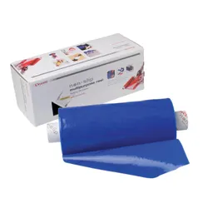  Purchasing Information

Who Might Benefit?
Those who…
• Use one hand for activities.
• Display jerky movement and/or tend to push objects away when trying to contact them.
• Slide around in their chair and have difficulty maintaining a comfortable or effective seated position.
• Have difficulty maintaining their grip on handles.

Why Use?
Provides an opportunity to…
• Stabilize objects, keep them in place, or improve grip.

Instructions for Use:
Environmental Considerations
- Place underneath toys, cups, bowls, plates, and clipboards to hold them in place.
Positioning
- Place on seats to help prevent child from sliding forward in the chair, or under the feet to help improve posture and positioning when sitting or standing.
- Place under positioning wedges, cushions, and/or pillows to prevent sliding.
Basic Play/Use
- Use as placemats beneath toys, puzzles or games to stabilize materials and keep drawing and marking tools from rolling out of reach.
- Wrap around handles, joysticks, eating utensils, or drawing/marking tools for easy gripping.
- Wrap around marker and glue stick lids to increase independence in removing them.
- Place on switches for sensory feedback.

