SPARK: Simple Play Adaptations to Reference for Kids

BIGMack
Description: | Image:
The BIGMack is a single message, Augmentative and Alternative Communication (AAC) device that supports those with limited to no speech throughout their daily activities. It offers a large picture display on the play button with easy set-up. The device is light weight for transport. Pressing the large button on the top of the device activates a single message. With each subsequent press of the button the same message is activated. The button is approximately 5” in diameter. Four different color top choices are provided, which snap over the activation button. The device comes with a clear snap cover allowing a picture symbol to provide communication context for the user. The BIGmack has 2 minutes of total record time. The device is powered by a 9-volt battery. | 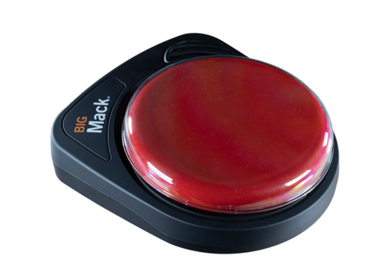  Purchasing Information  Quick Start Guide  Intro Video  Advanced Users Video  Users Manual

Who Might Benefit?
Those who…
• Have difficulty understanding only oral directions given by others.
• Have difficulty talking and communicating with others.
• Have difficulty completing multi-step activities (schedules, routines, directions).
• Have adequate fine motor skills to reach and press to activate the button on the device. This skill is specific to this device, however there are many different access methods that can be used with other communication devices if needed.

Why Use?
Provides an opportunity to…
• Make choices.
• Comment to others.
• View a multisensory (visual and auditory) non-transient cue (remains within view) to support following schedules, routines, and directions.
• Hear verbal directions paired with a visual cue as often as needed.
Instructions for Use: | Adaptation Ideas:
Environmental Considerations  - Can be easily used in almost any environment because of the small size, weight, and easy transportability.  - May be difficult to use in loud environments as the speaker on the device may not be loud enough to be heard by the child or communication partner over loud environmental noise.  - The user of the device will need to learn when it is appropriate to use the device in quiet environments in the same way that children who are speakers learn when they need to talk or not talk in quiet environments.  - If the device is used as a part of a child’s total communication system, it should be available in the child’s environment and without restriction, at all times.  Positioning  - Can be used in most any position due to the size, portability, and minimal weight (on a tabletop, attached to a wall with Velcro, placed on the floor, positioned on a slant board, etc.).  - Interact with the device in different positions such as sitting, standing, prone (Tummy Time position), supine (laying on back), kneeling, etc.  Alternate Positioning  - The BIGmack can be mounted onto the Ablenet Large Triangluar Mounting Plate (not included) and then on a variety of mounting systems that can be either connected to a table or wheelchair for alternate positioning if needed by the child. The linked guide provides directions for mounting.  Basic Play/Use  - Add one alkaline 9-volt battery to device (battery not included) and turn device on.  - Press and hold record button until recording indicator light turns on.  - Press and hold colored switch top. Begin speaking into microphone after you hear beep. When done recording message, release colored switch top.  - Press the record button to turn the recording indicator light off.  Extended Play/Use  - Provide directions, such as what to wear or what's next on the schedule.  - Make requests, such as ordering food, asking a question, or requesting a song.  - Participate in activities, such as turning the page, taking a turn, or repeating a phrase from a story (e.g. What do you see?).  - Share information, such as upcoming events or activities.  - Add communication to toys or appliances.  - Make games interactive, such as by modifying a game to talk or playing Simon Says.  - Use as labels for areas or centers, as teaching prompts, or to greet others upon entering the classroom every morning.  - Use to indicate the need to go to the bathroom by mounting outside the bathroom door, or provide the picture and recording to prompt a child to take a potty break.  Play/Use with Others  - Increase opportunity for communication by sending messages to others. | Optional Additional Materials/Supplies  - Dycem or shelf liner.  - Velcro  - Foam Board  Build It Up  - If the size of the button is too difficult for the child to activate, other switches and single message devices are available in the OCALI Lending Library that may have more sensitive or different types of activation surfaces.  Stabilize It  - Can be velcroed on most any surface so it doesn’t move away when the child tries to activate the button.  Add Sensory Cues  - Add sensory cues to the activation button such as puffy stickers, puffy paints, different textures.  - The color of the button can also be changed if needed.  Communication Support  - Vocabulary words will depend on the activity supported by the AAC device.  Alternative Uses  - Multiple BIGMacks can be placed side-by-side and velcroed onto a foam board strip to allow a child: choices among several toys or activities, providing a visual and auditory cue for the sequence and steps in an activity, provide first/then support, or to sequence and construct a simple sentence, etc.  - The device has a switch jack allowing a switch activated toy to be attached to the device so that pressing the device would activate the toy and a message simultaneously.  - A switch input jack is also on the device which allows an external switch to activate the message rather than the built-in button on the top of the device. This allows more customization of the size or sensitivity of the activation surface.

Additional Considerations:
- Please keep in mind the device only has 2 minutes of recording time. If additional recording time is needed there are other single message devices available in the OCALI Lending Library that could offer extended recording and play time.

Resources:
- 101+ Ideas for Single Message Communication Device Use - This article focuses on Ablenet single message devices.
- Using Single Message Devices - Tip of the month from TalkLink discussing the use of single message devices.
- Making the Most of Single Message Output Devices - A list of ideas on how to use single message devices provided by Enabling Devices.
- Keep Talking - This poster provides a quick reference and reminders for staff about the communication opportunities you can create with single message AAC devices. The poster was created by CALL Scotland, in collaboration with Tony Jones of TalkSens.

Ohio Early Learning Standards:
- Depending on the activities supported by the AAC device a wide range of Early Learning Standards could be impacted.
Words to Encourage Play/Use
Push  | Listen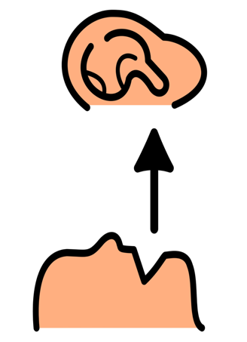 | All Done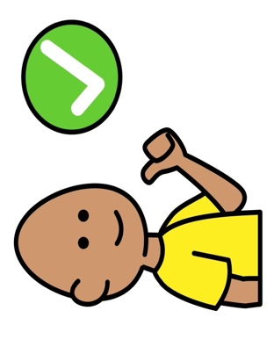
My Turn | Your Turn | More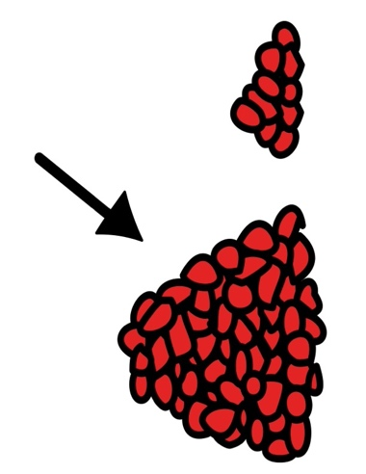
Wait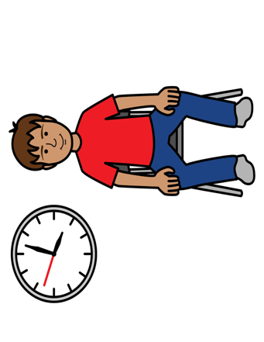 | Stop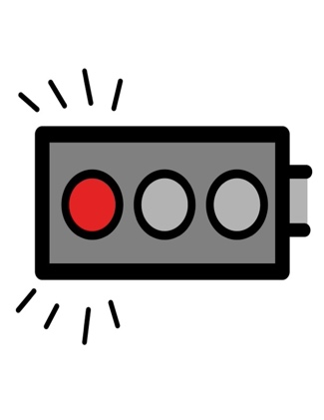 | Go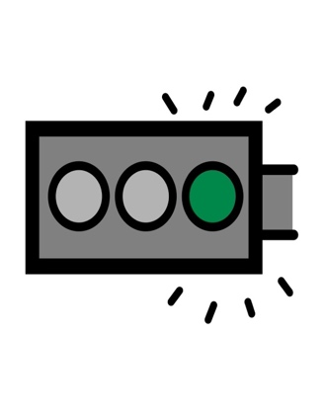
*”Adaptations” adapted from: Haugen’s Modes for Adapting Toys based on materials from the "Let's Play" Project at the University of Buffalo
PCS is a trademark of Tobii Dynavox, LLC. All rights reserved. Used with permission.

